In March 2020, due to Covid-19 the Government of India was forced to enforce a complete lockdown which immensely affected the Indian Market and all the businesses. The first lockdown was relaxed in June 2020. In the following year, the second Covid-19 lockdown was implemented in April 2021 and was lifted in June 2021. Incorporated in 1987, X is one of the India’s largest and highly regarded PVC pipe manufacturing and multi-polymer processors. They’ve been awarded the Brand of the Year – Pipes Award at INEX Reality+ Awards 2021. Y is a Pipes and Fittings Company which had a stronghold in South India was taken over by X in the Year 2017. In 2019 the company became a public limited company and was open for investors to invest in the company. Below is the graph showing us the overall trend of sales from 2015 to 2022 of Y. The considerable ups and down in the sales caused by the lockdowns made it difficult for the company to plan their production which led to the company facing a really high number of MNA (Material Not Available). As a solution to overcome this issue, the company decided to use the Forecasting method (Machine Learning). After a little R&D, it was discovered that the Holt-Winters model was the best fit for the company’s data. In this article we are about to see how the company used the Holt-Winters model to comprehensively plan the production of more than 7,167 products and extending this even to the distributor level which consists of 766 distributors across India.

Below is the graph with respect to the Tonnage from July 2015 to Dec 2021.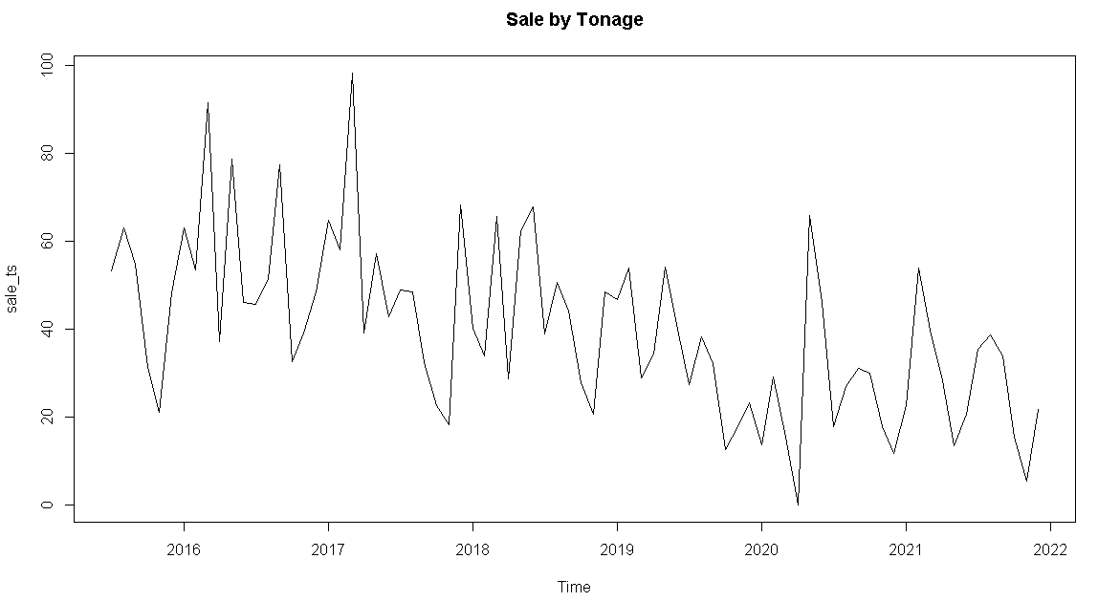

For better understanding. let us look at the covid affected regions.

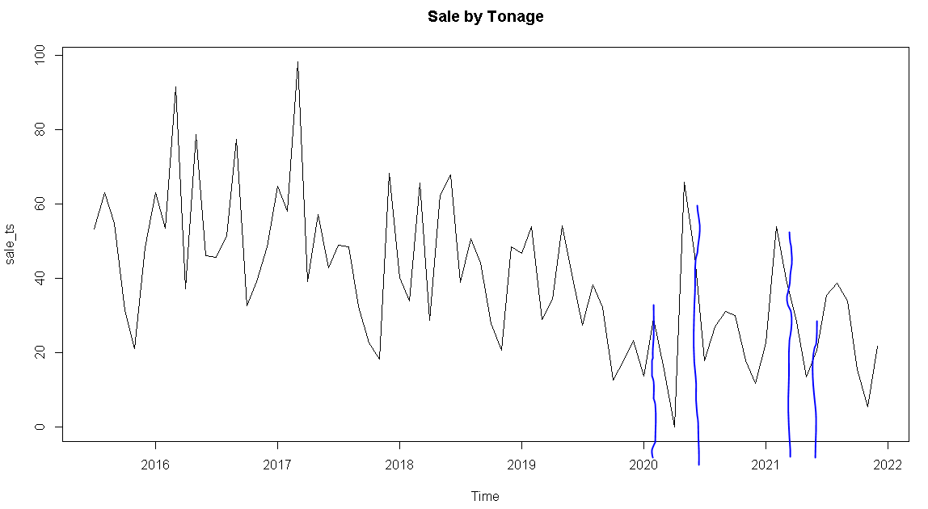

The region between the first 2 blue lines from the left is the lockdown affected region during the first lockdown (March 2020 to June 2020) and to the right is the lockdown affected region during the second lockdown (April 2021 to June 2021).

In order to do a successful forecast, we need to minimise the effect of lockdown as much as possible because the effect cannot be nullified completely. So we decided to do a forecast of the lockdown affected region and replace the original values by the forecasted value to minimise the effect of lockdowns.

Data Preparation:

The diagram shown below is the Data Processing goal we had to achieve.

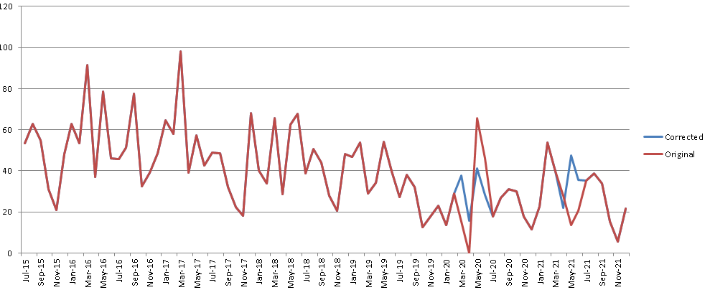

Replacing the lockdown affected values with the possible values had the lockdown not occurred. The red trend denotes Original values and the blue trend denotes the Corrected values.

We used Machine Learning in R to achieve the above.

First, we need to Import a few Libraries.

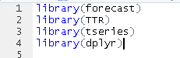

Later we Import the Data

df = read.csv("C:\\Users\\rdp\\Documents\\Excel\\”File Name” - Sales Data.csv")

We use Select to Shortlist the Important Columns Required for our time series forecasting and then we Summarise the Tonnage sold during the same Period

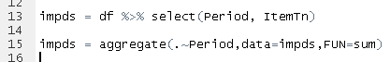

We check if the Data is Prepared to be fitted inside the modal

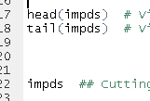

We Split the Data into 5 different parts

Part 1: Before the First Lockdown

Part 2: During the First Lockdown (March 2020 to June 2020)

Part 3: Between the First and the Second Lockdown

Part 4: During the Second Lockdown (April 2021 to June 2021)

Part 5: After the Second Lockdown

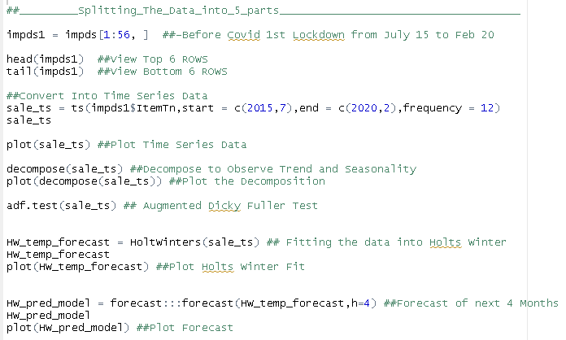

We Split the data and use Part 1 depending on the Decomposition of part 1 we learn that Trend and Seasonality Exists hence we decide to go ahead with the Case 3 of Holts Winter where Alpha = TRUE , Beta = TRUE and Gamma = TRUE (Level, Trend and Seasonality Exists)

We Get

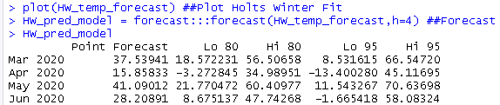

We have to replace these Forecast Values with the Original Values to do so we first need to convert the Forecast Values to a Data frame

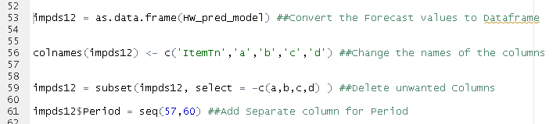

We Convert the forecast values to a data frame and then we change the column names, we remove the unnecessary columns like High and Low Confidence Interval and add a separate period column

Now we have to replace the forecast value with the original value

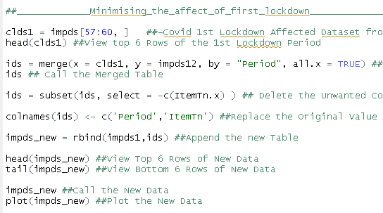

We callout the Part 2 data that is of the first Lockdown and we merge the 2 data frames creating a separate data frame after which we delete the column from the Original data frame and Replace the Original Values with the forecast Values and then Append the part 2 df to part 1 df (Add the part 2 Data frame below part 1 Data frame) and create an entirely new Data Frame

Moving on to part 3

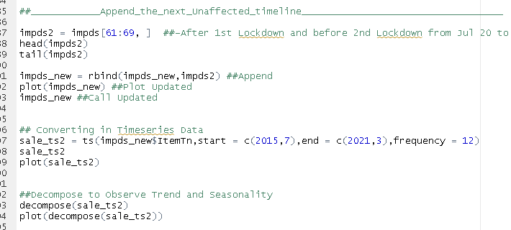

Part 3 is the unaffected timeline which took place between the first lockdown and the second lockdown we append (add below) the part 3 timeline to new data frame and then convert it to time series data after which we decompose the data and learn that Level, Trend and Seasonality Exists and hence we again use Case 3 of Holts Winters Model and Repeat the same process for forecasting the value of Part 4 which is the affected timeline of 2nd lockdown replacing the values of the part 4 re append part5 and now our data is ready for forecasting

We get

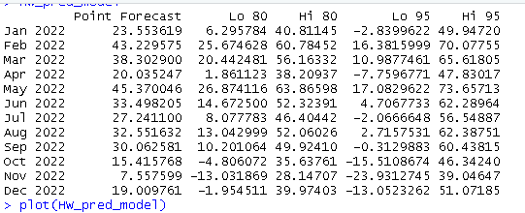

Let us check the Accuracy of the Model By splitting the Data into Train and Test

Train: July 2015 to June 2021

Test: July 2021 to December 2021

Over here we fit the Holts winter Forecast Model in the Train Data for the above mentioned time period and calculate the forecast for next 6 months and compare it with the Test Data for the above mentioned time period

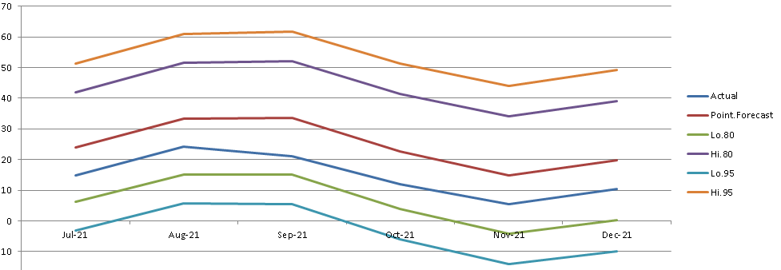

As we can see that The Red Line is the Forecast trend and Blue is the Actual Value as we can observe from the Graph Our Predicted Value lies under 80% Confidence Interval and RMSE of 10.11375

Using this forecast Model the Company would plan their production for the coming Future